**201533661 이승수’s data science minilab2**

1. **Linear regression with all data**

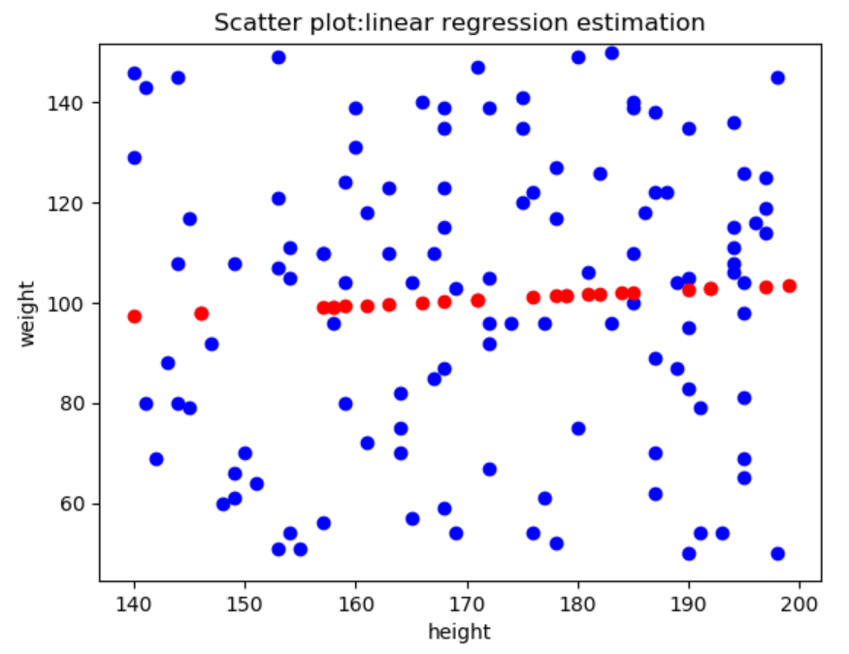

1. **Linear regression with male data**

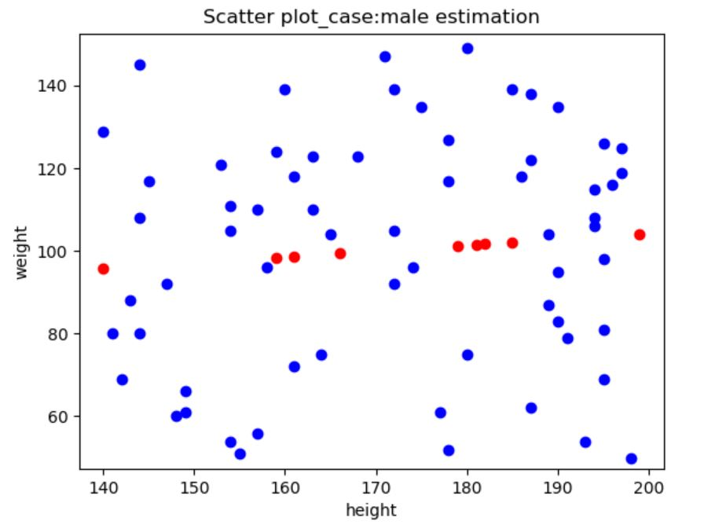

1. **Linear regression with female data**

